**Title: Temperature driven increases in interspecific but not intraspecific body sizes in German stream macroinvertebrate species across two decades**

**Authors:** David Mittag1, Nathan Jay Baker2*, Laura H. Antão3, Lucie Kuczynski4, 5, Peter Haase1,6, Ellen A. R. Welti1,7

**Author Affiliations**

1 Department of River Ecology and Conservation, Senckenberg Research Institute and Natural History Museum Frankfurt, Germany

2 Institute of Ecology, Nature Research Centre, Vilnius, Lithuania

3 Organismal and Evolutionary Biology Research Programme, Faculty of Biological and Environmental Sciences, University of Helsinki, Helsinki, Finland

4 Institute of Chemistry and Biology of Marine Environments [ICBM], Carl-Von-Ossietzky University of Oldenburg, Wilhelmshaven, Germany

5 UMR ENTROPIE, IRD, IFREMER, CNRS, University of La Reunion, University of New Caledonia, Noumea, New Caledonia

6 Faculty of Biology, University of Duisburg-Essen, Germany

7 Great Plains Science Program, Conservation Ecology Center, Smithsonian Institution, Bozeman, MT, USA

* corresponding author: nathan93Baker@gmail.com

**Keywords:** stream, river, long-term, ecology, temperature, insect, global change

**Abstract**

The Anthropocene has accelerated changes among species (i.e. turnover) as well as within species globally, likely altering the functional trait composition of ecological communities. Body size is expected to decline with climate warming, with implications for ecosystems’ structure and functioning, such as production, resource use, and food provisioning for predators. To test for temporal changes in body size, we measured body sizes for nine common macroinvertebrate species representing different taxonomic orders and classes in four German streams belonging to the eLTER site Rhine-Main-Observatory sampled between 2001 and 2019. We examined both inter- and intraspecific body size shifts over time and with water temperature, and also assessed the relationship between a given taxa’s body size and its abundance temporal trends within the four streams. There was high variability in intraspecific changes in body size over time, and temperature was not a strong predictor of these trends. In contrast, weighted means of body size across species increased over time, with warmer sites being dominated by larger taxa. Additionally, larger taxa tended to have greater increases in abundance over time. Our findings do not align with previous predictions of negative effects of rising temperatures on invertebrate body sizes, and highlight the importance of xxxx. Other changes in the system including improvements in water quality over time, may underlie body size shifts in this system. Quantifying changes in body size across and within-species provides key insights into the processes and dynamics of biodiversity change in a rapidly changing world.

**Introduction**

Body size is a fundamental characteristic of all animals (Brown *et al.*, 2004), linked to physiological, life-history, and ecological traits of organisms. In addition, shifts in body sizes have direct implications for species’ populations, ecological communities, and ecosystem energy flows (Daufresne *et al.*, 2009; Santini & Isaac, 2021) - body size can affect nutritional needs, fecundity, dispersal ability, and the likelihood of being consumed by predators (Chown *et al.*, 2010), thus impacting interspecific interactions (Chown *et al.*, 2010; Horne *et al.*, 2017), which can directly alter ecosystem functioning. For example, larger species are more effective pollinators (Willmer & Finlayson, 2014), while predator-prey interactions (with few exceptions, e.g., host-parasite relationships) as well as basal food-web dynamics (i.e., decomposition and production) are size-delimited (de Roos & Persson., 2002; Scheffer & Carpenter, 2003; Woodward et al., 2005).

Four hypotheses predict shifts in animal body size over time and space. First, body size tends to increase with latitude across species, a phenomenon known as ‘Bergmann’s rule’ (Bergmann, 1848), which applies to many endothermic taxa (e.g. Meiri & Dayan, 2003) but is less validated for ectotherms (Audzijonyte *et al.*, 2019). The latitudinal gradient in temperature is the hypothesized mechanism underlying Bergmann’s rule (Horne *et al.*, 2017). Second, ‘James’ rule’ predicts that within species, warmer areas host smaller individuals. This rule holds along spatial thermal clines for both endothermic (James, 1970; Henry *et al.*, 2022) and ectothermic species (Killen *et al.*, 2010; Deutsch *et al.*, 2022) . Third, the Temperature-Size Rule (TSR) predicts declining body sizes with rising temperatures. This pattern has primarily been ascribed to smaller animals having increased heat tolerance due to larger surface area to volume ratios, with examples for fish (Huss *et al.*, 2019) and birds (Weeks *et al.*, 2022). However, evidence in ectotherms remains mixed, with few studies examining long-term shifts in invertebrate body sizes (Walters & Hassall, 2006; Chown *et al.*, 2009; Shelomi, 2012; Horne *et al.*, 2017; Brehm *et al.*, 2019). Smaller body sizes, and thus larger surface area to volume ratios, can also be an advantageous trait that increases the ability for oxygen exchange in freshwater ecosystems (Daufresne *et al.*, 2009, Verberk *et al.*, 2021). This need is exacerbated due to the low oxygen availability underwater (>5 orders of magnitude lower than air) and the increased need for oxygen with increasing metabolic rate as temperatures rise. Oxygen levels in water further decrease with increasing temperature, with likely repercussions for community composition of freshwater systems as water temperatures increase (ref?). Due to this additional oxygen constraint, aquatic species are expected to more closely adhere to TSR than terrestrial species (Forster et al., 2012).

Fourth and finally, shifts in phenology can affect the body size for different life stages over the growing season (Chown & Gaston, 2010; Horne *et al.*, 2017a). Invertebrate life cycles can be adapted to seasonal shifts in resources as well as hydrological, thermal, and light regimes. Climate change is affecting all of these potential cues (Kwon et al. 2019). In particular, warmer temperatures are expected to shift growing seasons earlier, resulting in earlier invertebrate emergence in temperate climates (Linderholm 2006; Verheyen et al., 2018). These shifts may be especially strong for organisms with short generation times such as invertebrates. For univoltine species (i.e., reproducing once a year) like many freshwater insects, earlier emergence is expected to lead to increased body size over time for a fixed time point/sampling period in the growing season (Chown & Gaston, 2010). For multivoltine taxa (i.e., reproducing at least twice a year), predicting body size shifts across years at a given seasonal time point in response to earlier emergence becomes more challenging, as shifts can capture different generations (Walters *et al.*, 2006). Understanding seasonal shifts is important as they can have repercussions for predators relying on food sources at particular periods, such as taxa that rear their offspring and provision them with invertebrate prey (Kwon et al. 2019).

Here, we investigate decadal responses in body size leveraging a long-term collection of aquatic macroinvertebrates from central Germany. We measured 3,427 individuals from nine common macroinvertebrate species collected in four sites between 2001 and 2019. We quantified both inter- and intraspecific trends and variability over time and examined responses to water temperature over time (Fig. 1). We tested several specific hypotheses. First, if temperature increases are driving responses in accordance with TSR, we predict that intraspecific body size will decrease through time (H1a). Second, if phenological shifts associated with changing climate conditions are driving responses, we expect intraspecific body size of univoltine macroinvertebrate taxa to increase through time, and mixed responses for multivoltine taxa as a result of earlier growing seasons and hatching (H1b). We expect shifts in average interspecific body size to mirror changes in intraspecific body size with responses to temperature resulting in decreasing interspecific body size (H2a) or earlier emergence resulting in increases in interspecific body size (H2b) over time.

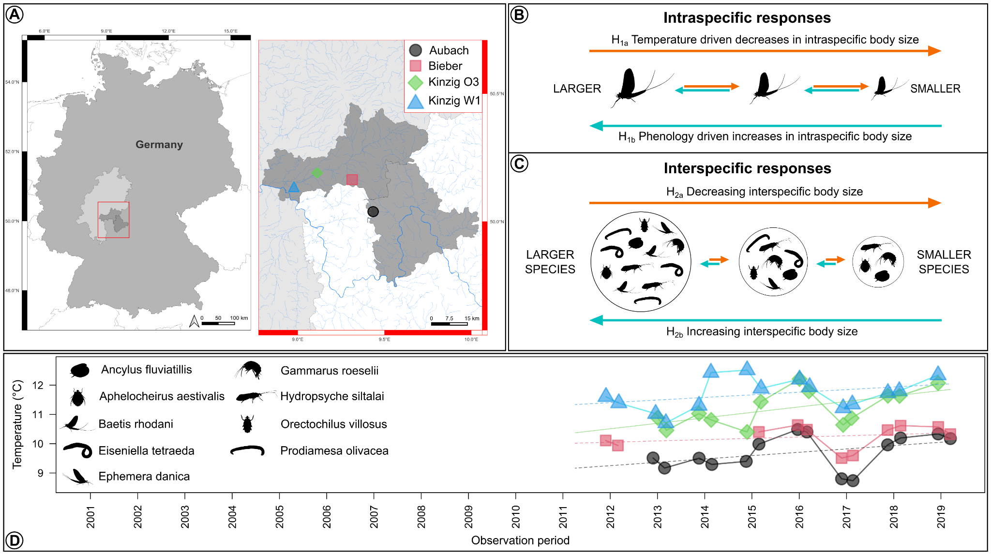

**Figure 1**. **Study location and sampling sites (A), hypothesized variation in intraspecific (B) and interspecific (C) invertebrate body size in response to temperature and phenology, and changes in annual temperatures through time (D).** In B and C, silhouettes used are for illustrative purposes only and do not reflect study results. In D, solid lines indicate a significant (p ≤ 0.05) temperature trend. Invertebrate silhouettes are indicative of the investigated species.

**Methods**

*Study sites*

Four sites located in Central Germany were chosen as the focal points of our study (Fig. 1): Kinzig O3, Kinzig W1, and Bieber are situated within the Kinzig River drainage basin (~1060 km²) and are included as part of the eLTER (Mirtl et al. 2018) site Rhine-Main-Observatory (RMO). The other site, Aubach, is located next to the RMO and has been - like the other three sites - continuously monitored over almost two decades, making it one of the longest consecutively observed sites in the region. Both the Aubach (via the Lohr river) and Kinzig rivers are tributaries of the Main river, a major contributor to the Rhine river. RMO encompasses diverse environments, ranging from densely populated regions on the outskirts of the Rhine-Main metropolitan area to unimpacted natural landscapes, and including a wide array of land use types. The four selected sites reflect this land use range, with Bieber and Aubach representing streams that have experienced less anthropogenic perturbation, while the two Kinzig sites exhibit higher levels of human impact. Average elevation across the RMO is 110 m.a.s.l, while mean annual air temperature and precipitation are 9.62℃ and 837.88 mm, respectively. Further details of the RMO can be found at <https://deims.org/9f9ba137-342d-4813-ae58-a60911c3abc1>.

*Field sampling*

Macroinvertebrate communities in these sites were sampled biannually (spring: March or April and summer: June or July) between 2001-2019 for Aubach and Bieber (2005 missing for the latter), and between 2005-2019 for the two Kinzig sites. Sampling followed the European Water Framework Directive’s standardized multi-habitat sampling protocol (Haase et al. 2004) with 20 subsamples collected from a 100m section of stream at each sampling site and period. Specimens were then preserved in 70% ethanol, identified primarily to genus and species levels using an operational taxa list (Haase et al. 2006), and deposited in the natural history collections at the Senckenberg research station in Gelnhausen, Germany.

*Measuring body size*

We measured body sizes of xxx individuals from nine aquatic macroinvertebrate taxa. We selected species based on their prevalence across all sites over the time-series and spanning different representative invertebrate groups and life histories (Table 1). In total, we measured head size and total body length of 848 *Ephemera danica* (Ephemeroptera), 643 *Baetis rhodani* (Ephemeroptera), 390 *Hydropsyche siltalai* (Trichoptera), 510 *Prodiamesa olivacea* (Diptera), 320 *Aphelocheirus aestivalis* (Hemiptera), and 94 *Orectochilus villosus* (Coleoptera). For the limpet *Ancylus fluviatilis* (281, Gastropoda), the shell length, width, and height was measured. For the worm *Eiseniella tetraeda* (135, Annelida) the body length and width was measured. For the 206 *Gammarus roeselii* (Gammaridae), body length and length of the first antennae was measured.

**Table 1.** Relationship between modeled temporal changes (**𝚫)** in abundance, body size, and head sizes and species-specific voltinism. Mean body length and head size are averages *± standard error.* Change in abundance provides an overall trend for the taxa *±* trend *standard error* (gls estimate of year for a model of abundance ~ year + Second degree polynomial of day year + site). Downward and upward arrows indicate significant decreasing and increasing size trends, respectively, while no change is indicated by horizontal arrows. Taxa are listed from largest to smallest body length.

| **Species** | **Group** | **Mean body length** | **Mean head size** | **𝚫 Abundance** | **𝚫 Body length** | **𝚫 Head size** | **Voltinism** | **References** |
| --- | --- | --- | --- | --- | --- | --- | --- | --- |
| *Eiseniella tetraedra* | Oligochaeta | 27.29 *± 0.86* | 2.19 *± 0.06* | →  0.06 *± 0.07* | →  -1.76 *± 1.97* | →  -0.03 *± 0.08* | Univoltine | Tachet et al., 2010 |
| *Ephemera danica* | Ephemeroptera | 14.94 *± 0.20* | 1.32 *± 0.02* | **↗**  **0.27 *± 0.04 \*\*\**** | **↘**  **-0.64 *± 0.27***  ***\**** | **↘**  **-0.10 *± 0.02***  ***\*\*\**** | Voltinism plasticity - semivoltine | Bennett, 2007 |
| *Gammarus roeseli* | Amphipoda | 12.69 *± 0.27* | Not measured | **↗**  **0.28 *± 0.08 \*\*\**** | **↘**  **-1.28 *± 0.3***  ***\*\*\**** | Not measured | Voltinism plasticity - bivoltine, multivoltine | Grabowski et al., 2007 |
| *Orectochilus villosus* | Coleoptera | 10.59 *± 0.27* | 0.61 *± 0.02* | →  -0.04 *± 0.07* | →  -0.35 *± 0.29* | →  0.03 *± 0.02* | Univoltine | Tachet et al., 2010 |
| *Hydropsyche siltalai* | Trichoptera | 9.67 *± 0.17* | 1.12 *± 0.02* | **↘**  **-0.17 *± 0.06 \*\**** | →  -0.04 *±0.1* | →  0.02 *± 0.01* | Univoltine | Anderson & Klubnes, 1983 |
| *Prodiamesa olivacea* | Diptera | 9.62 *± 0.14* | 0.52 *± 0.01* | →  -0.01 *± 0.08* | **↗**  **0.99 *± 0.13 \*\*\**** | **↗**  **0.04 *± 0.01***  ***\*\*\**** | Voltinism plasticity - bivoltine | Schmid, 1992 |
| *Aphelocheirus aestivalis* | Hemiptera | 6.27 *± 0.14* | 1.57 *± 0.02* | →  0.06 *± 0.08* | →  -0.20 *± 0.18* | →  -0.02 *± 0.03* | Univoltine | Tachet et al., 2010 |
| *Baetis rhodani* | Ephemeroptera | 5.93 *± 0.08* | 0.92 *± 0.01* | **↘**  **-0.1 *± 0.04 \**** | **↘**  **-0.33 *± 0.07 \*\*\**** | **↘**  **-0.06 *± 0.01 \*\*\**** | Voltinism plasticity - univoltine, bivoltine, multivoltine | Sand & Brittain, 2008 |
| *Ancylus fluviatilis* | Gastropoda | 4.8 *± 0.08* | Not measured | →  0.1 *± 0.06* | →  -0.08 *± 0.08* | Not measured | Univoltine | Tachet et al., 2010 |

Up to 10 individuals per probe were chosen randomly. Specimens were measured under a microscope using calipers (0.01 mm accuracy). As Gammarus roeselii specimens usually bend, all specimens were brought into a similar pose and then measured by drawing a line from the specimen’s head to the urosome using a microscope camera connected to a computer with the software Cell^A.

*Stream temperatures*

From 2011 onwards, biological datasets of each site were supplemented with in-stream temperature measurements, taken hourly or bihourly via automatic temperature loggers. In cases where temperature time series contained missing data (due to the loggers malfunctioning or being lost), data were interpolated using the ‘interpolate_gaps_hourly’ function in the *chillR* R package (Luedeling et al., 2023). When interpolation was unable to provide satisfactory temperature estimates due to gaps in the dataset being larger than 2% of the time-series, interpolated data were removed and left blank. Interpolated hourly temperature data were then aggregated to daily means and used to calculate mean temperatures from the 365 days prior to the date of biological sampling. The 12-month interval was selected as most European aquatic invertebrates have univoltine life cycles (68% of taxa listed in Tachet et al., 2010). For example, if biological sampling was conducted on June 12th of a given year, the mean temperature for this day was calculated using daily mean temperatures from June 12th of the prior year to June 11th of the sampling year. Previous-year mean temperatures were only calculated if daily mean temperature data were available for >98% (360 days) of the days leading up to the biological sampling. This approach generated temperature datasets for 53 site-years (40.5%), which were used to explore temporal relationships between intra- and inter-specific body size and temperature.

*Statistical analyses*

We analyzed changes over time in both the intraspecific body sizes of the nine focal species, and interspecific body size structure of the macroinvertebrate “community”, by pooling the data together per site and year. Body size classes for species and other traits were extracted from the DISPERSE database (Sarremejane et al. 2020) and freshwaterecology.info (Schmidt-Kloiber and Hering 2015). Intraspecifically, we analyzed change in body size over time for each species, while accounting for the day of year (phenology), intraspecific density from the same sample (intraspecific density dependence), and sampling sites. Interspecifically, we analyzed the overall change in Community Weighted Mean (CWM) of body size with year pooling the data across all four sites, while accounting for day of year and sampling sites. For both analyses, we used generalized linear mixed models using the “lmer” function in the R package lme4 (Bates et al. 2015). We further modeled CWM responses to year of sampling for each site while accounting for sampling day of year using linear regression. The response of CWM to mean temperature in the prior 12 months was found to fit a third degree polynomial; we modeled this relationship in a post hoc analysis using Program R’s “poly” function within a linear model. Finally, we analyzed the abundance trends over time for the 59 most common species (i.e. species present in at least 12 samping years), and tested whether species body size predicted abundance trends. Models for common species were fitted using generalized least squares models using the function “gls” in the R package nlme (Pinheiro et al. 2023). In all cases when sampling day of year was included in tests, it was modeled as a second degree polynomial to account for seasonal trajectories. All models were fit in R, ver. 4.2.2. (R Core Team, 2024). All code for analyses is included in the github repository: https://github.com/Ewelti/BOSCH.

**Results**

The nine measured macroinvertebrates ranged in body size from the smallest species, the limpet *A. fluviatilis* (average body length: 4.8 mm ± 0.08 SE), to the largest species of the worm *E. tetraedra* (27.29 mm ± 0.86 SE). A total of 223 taxa were collected over all years and across the four sites. The temperature at each of the four sites tended to increase through time, with average annual increases of 0.003°C at Aubach ( p = 0.15), 0.001°C at Bieber (p = 0.42), 0.006°C at Kinzig O3 (, p = 0.03), and 0.003°C at Kinzig W1 (, p = 0.17).

*Intraspecific body size patterns*

There was strong variation in changes in body size within species, including declining(n = XXX), increasing (sps==) and stable trends over time (n = XXX) (Fig. 2, Table xx). Specifically, the two Ephemeroptera, *B. rhodani* and *E. danica*, decreased in both body length and head width over time, while the amphipod *G. roeselii* decreased in body length (Fig. 2 & S1, Tables S1 & S2). The limpet *A. fluviatilis*, the hemipteran *A. aestivalis,* the worm, *E. tetraedra*, and the trichopteran *H. siltalai*, did not vary in body size over time on any measured body component, while the midge *P. olivacea* increased over time in both body and head length (Fig. 2, Table S1 & S2).

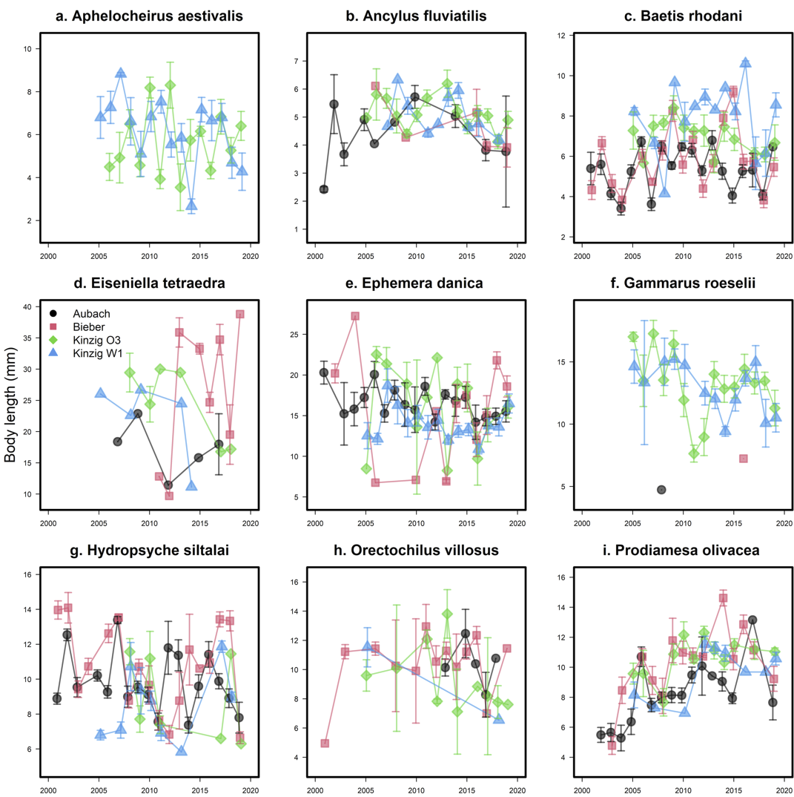

**Figure 2.** Changes in intraspecific body length over time and in the four study sites for nine freshwater aquatic macroinvertebrate species: *Aphelocheirus aestivalis* (a), *Ancylus fluviatilis* (b), *Baetis rhodani* (c), *Eiseniella tetraeda* (d), *Ephemera danica* (e), *Gammarus roeselii* (f), *Hydropsyche siltalai* (g), *Orectochilus villosus* (h), and *Prodiamesa olivacea* (i).

For all species, changes in body size over time were not well explained by temperature over the previous 12 month period (R2 ranging from XXX to XXX). *A. fluviatilis*, which showed no change over time (Fig. S2, Tables S1, S2, & S3), was the only species withincreasing body length, height, and width in warmer years (Fig. S3, S4 & S5, Tables S4, S5, & S6)

*Interspecific body size patterns*

Contrary to the mixed intraspecific body size shifts, CWM of interspecific body size increased over time overall (year estimate across all four sites = 0.06, SE = 0.01, *P* < 0.001), with larger species increasing in abundance over time (Fig. xxx, Table xxx). Evaluating the trends per site, CWM increased at Aubach (Year Est. = 0.06, SE = 0.02, *P* = 0.01), Bieber (Year Est. = 0.12, SE = 0.02, *P* < 0.001), and Kinzig W1 (Year Est. = 0.07, SE = 0.02, *P* < 0.001), but not Kinzig O3 (Year Est. = 0.02, SE = 0.02, *P* = 0.31; Fig. 3a). Further, CWM increased and then plateaued with water temperature (third degree polynomial of temperature estimate across all four sites = -0.83, SE = 0.26, *P* = 0.003; Fig. 3b). When assessing changes for the 59 most common species that allowed sufficient quantification of temporal trends, we found that despite abundance trends being variable among species, larger species increased more their overall abundance over time (Year Est. = 0.04, SE = 0.01, *P* = 0.02; Fig. 4). However, this trend was not significant at the site level (Aubach: Year Est. = 0.02, SE = 0.03, *P* = 0.44; Bieber: Year Est. = 0.04, SE = 0.03, *P* = 0.17; Kinzig O3: Year Est. = 0.07, SE = 0.05, *P* = 0.2; Kinzig W1: Year Est. = 0.04, SE = 0.05, *P* = 0.41; Fig. 4).

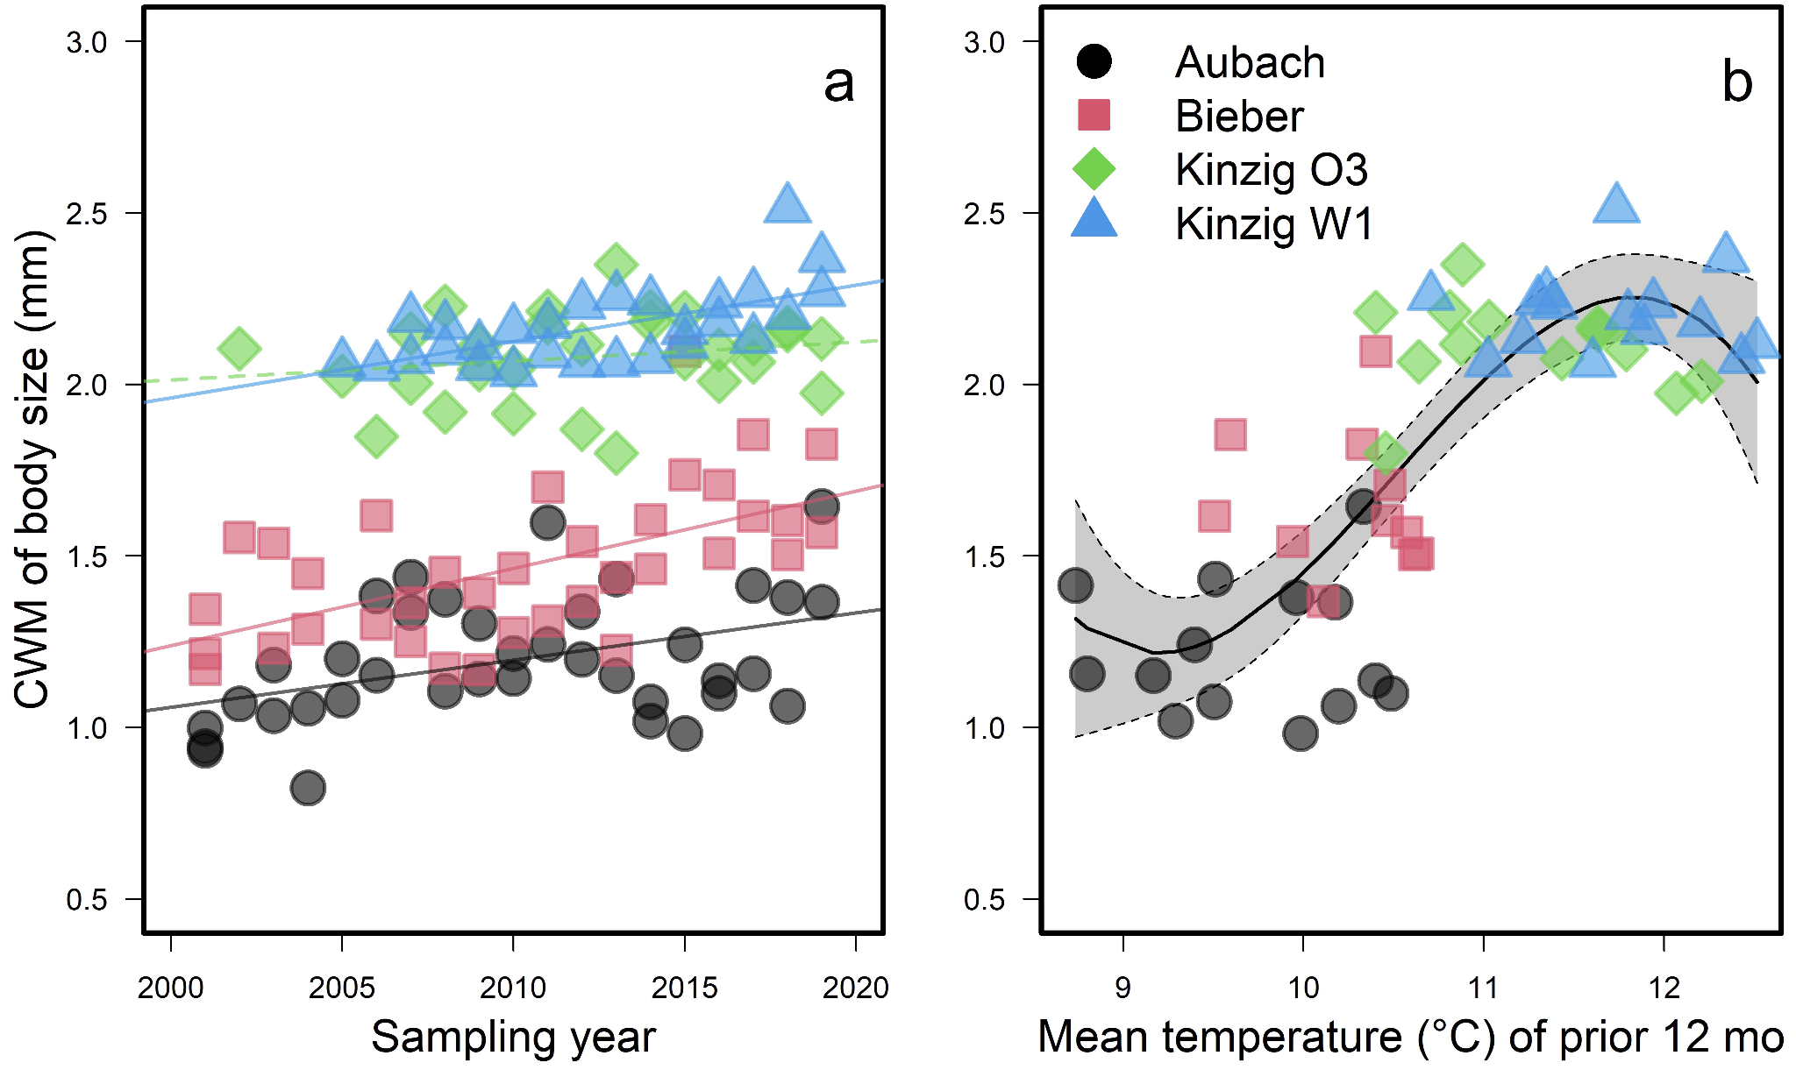

**Figure 3.** Change in the Community Weighted Mean (CWM) of interspecific body size over time (a) and water temperature (b). In panel a, dashed lines indicate non-significant (*P* > 0.05) changes over time while solid lines indicate a significant time effect.

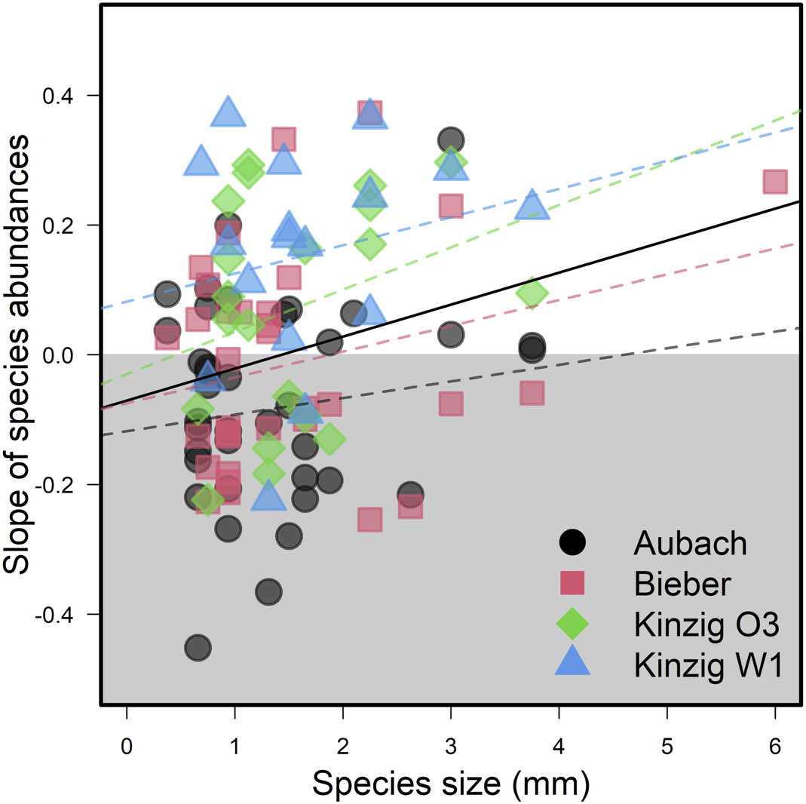

**Figure 4.** Change in species abundances over time (slope), regressed over species interspecific body sizes. Each point represents the estimated slope of one species within one site, using only species sampled for at least 12 years. Dashed lines show regression relationships for each sites (all non-significant), while the solid black line shows the relationship for all sites.

**Discussion**

Animal body size has ecological consequences across biological levels, from an individual’s risk of predation to a community’s use of resources (Horne *et al.*, 2017b). Intraspecifically, we found divergent trends for the nine freshwater macroinvertebrate species we measured across two decades. Species that do not have strictly univoltine life cycles had the greatest shifts in body size over time. Specifically, body size of the two Ephemeroptera species (one bivoltine or multivoltine, and one mostly semivoltine, and in rare cases univoltine)and the gammarid (bivoltine or multivoltine) decreased, the midge (bivoltine) increased, and five species (all univoltine) did not exhibit changes over time. This suggests changes in emergence time are more important in this system and studied time period than changes in temperature-induced decreases that we predicted. Interspecifically, we found both a shift in community composition resulting from larger species being more likely to increase in abundances over time (i.e., rather than a loss of small species).

***Intraspecific variation in body size***

Alongside changes to phenology and distribution, body size reductions have been suggested to be a third universal response of organisms to global environmental change (Gardner et al., 2011). By contrast, we found no unified patterns of temporal changes in intraspecific body size across the nine analyzed species, which is consistent with some previously reported responses for insects (Martins et al., 2023) and fish (Audzionyte et al., 2020). A lack of overarching responses could be due to the importance of other drivers such as shifts in stream nutrients or runoff, could reflect poor alignment with annual temperatures (the scale selected for this study), or changes in temperature may not yet be large enough to have strong effects on body size. Interestingly, species that showed temporal changes in intraspecific body size, including both increases and decreases, were always associated with voltinism plasticity (*B. rhodani, E. danica, G. roeselii, P. olivacea*), i.e. species capable of adjusting the number of generations they have per year depending on prevailing environmental conditions. On the other hand, organisms with “strict” voltinism life cycles (*A fluviatilus, A aestivalis, E. tetraedra, H. siltalai, O. villosus*), showed no general changes in body size over time, indicating a higher dependence on seasonal predictability. Taken together, these findings suggest phenological shifts are stronger drivers of intraspecific body size variation compared to temperature and other drivers, which are more likely to impact intraspecific body size, at least over these 16-19 year periods.

The interplay between changes in thermal and phenological regimes cannot be easily disentangled. Broadly speaking, the responses we observed can be categorized into three main scenarios. First, five “strictly” univoltine species (*A fluviatilus, A aestivalis, E. tetraedra, H. siltalai*, and *O. villosus),* showed no strong changes in body size through time. The lack of change could potentially be due to the effects of increasing temperature and shifting phenology balancing each other out. For example, if phenological shifts cause a univoltine species to hatch earlier than usual (ref), then one would expect, given sampling season consistency, that the sampled individuals would be larger for a given sampling date. However, if the effects of increasing temperature cause the same individuals to have smaller body sizes (i.e., the temperature-size rule) (ref), then the effects of earlier development could be counteracted, leaving univoltine species the same general size, but at potentially different developmental phases. Second, the chironomid (*P. olivacea)* demonstrates voltinism plasticity and was the only species that became larger through time. This increase in body size is likely related to earlier emergence patterns and longer growing seasons. Third, three species (*B. rhodani, E. danica*, and *G. roeselii)* which also have voltinism plasticity,declined in body size through time. These species also likely emerged earlier later in the time series, with sampling then starting to include individuals collected at the beginning of a new generation cycle. A larger caveat of our analysis is that developmental stage was not noted during species measuring and we are therefore unable to say with certainty that the changes in body size are linked to earlier emergence, especially for the species which show voltinism plasticity. Regardless, difference in body size responses for univoltine species compared to those with voltinism plasticity suggests shifts in phenology is a likely mechanism of intraspecific body size shifts.

***Interspecific variation in body size***

Macroinvertebrate interspecific body size increased over the research period at the two colder and smaller streams of Aubach and Bieber, as well as at the warmer and larger river sites of Kinzig O3 and W1. Body size of macroinvertebrates at the Kinzig sites were also larger overall, but the gap between these and the two colder and smaller streams shrank over the course of study. Larger body sizes may be beneficial for the stronger currents experienced at the two Kinzig sites. Responses of macroinvertebrate community body sizes to water temperature followed a sigmoid pattern, with a rapid increase in size with temperature in cold waters, to a plateau at temperatures above 12°C. Additionally, interspecifically larger species have become more abundant over time, while smaller species are more likely to be experiencing population declines. These results are contrary to the expectation that warmer temperatures favor taxa with smaller body sizes (Daufresne *et al.*, 2009). This suggests that either larger species in this system are more adapted to warmer water conditions, or parallel changes in these systems in favoring large species. Parallel changes that were untested in this study could include shifts in stream nutrients and flow. A potential untested driver is improvements in water quality in the studied streams due to regulation and restoration efforts (Nguyen et al. 2024). The benefits of water quality improvements for oxygen availability and reduced toxicants may aid recovery of larger stream taxa (Deutsch et al. 2022). Overall, our results are indicative of the difficulties in teasing out causality in long-term observational data and specific mechanisms should be investigated using experimental methods (Runge et al. 2019). Unexpectedly favorable conditions for large taxa counters the current literature’s current predictions for long-term change, highlighting a stream system with unexpected responses deserving further inquiry.

***Conclusion***

Studies of how invertebrate body sizes vary over time have lagged behind vertebrate species and communities (Chown & Gaston, 2010; Wonglersak *et al.*, 2020). Intraspecifically, increases in environmental temperature can lead to faster developmental rates but smaller size at maturity of ectothermic species. Many insects have complex life cycles, varying in voltinism type, and co-occurring and often unmeasured changes in potential drivers make it difficult to separate the effect of temperature from other environmental shits (Horne *et al*., 2017; Brehm *et al*., 2018; Daufresne *et al*., 2009). Across freshwater macroinvertebrate taxa collected over 19 years of sampling we found trends over time in intraspecific body sizes for four species with voltinism plasticity but not five univoltine species, suggesting species with shorter or more variable life cycles have outsized effects on community changes. This system further saw increases in both average body size, and larger species were more likely to increase in abundance than smaller taxa, potentially indicative of a local ecological recovery. Sorting out effects of the myriad of potential drivers of shifts in animal body size remains a priority, especially for invertebrates.

**Acknowledgements**

We thank Natalie Kaffenberger and Beatrice Kulawig for their dedication to the long-term sampling of freshwater macroinvertebrates and assistance in the lab. Funding was provided to P.H. and E.A.R.W. from the EU Horizon 2020 eLTER PLUS (Grant Agreement No. 871128) and from the eLTER PLUS Transnational Access grant: BOSCH: BOdy Size CHanges to E.A.R.W., L.K. and L.H.A.. L.K. further acknowledge funding by the German Science Foundation funded research unit DynaCom (FOR 2716, DFG HI 848/26-1). L.H.A acknowledges funding from the Research Council of Finland (grants 340280 and 361416).

**References**

Baselga, A. (2010) Partitioning the turnover and nestedness components of beta diversity. *Global Ecology and Biogeography*, 19, 134–143.

Bergmann, C. (1848) *Über die Verhältnisse der Wärmeökonomie der Thiere zu ihrer Größe*,.

Brehm, G., Zeuss, D. & Colwell, R.K. (2019) Moth body size increases with elevation along a complete tropical elevational gradient for two hyperdiverse clades. *Ecography*, 42, 632–642.

Brown, J.H., Gillooly, J.F., Allen, A.P., Savage, V.M. & West, G.B. (2004) Toward a metabolic theory of ecology. *Ecology*, 85, 1771–1789.

Crisp, M. & Cook, L. (2012) Phylogenetic niche conservatism: What are the underlying evolutionary and ecological causes? *The New phytologist*, 196, 681–94.

Daufresne, M., Lengfellner, K. & Sommer, U. (2009) Global warming benefits the small in aquatic ecosystems. *Proceedings of the National Academy of Sciences*, 106, 12788–12793.

de Roos, A.M. & Persson, L. (2002) Size-dependent life-history traits promote catastrophic collapses of top predators. *Proceedings of the National Academy of Sciences of the United States of America*, 99, 12907–12912.

Dornelas, M., Antão, L.H., Moyes, F., Bates, A.E., Magurran, A.E., Adam, D., Akhmetzhanova, A.A., Appeltans, W., Arcos, J.M., Arnold, H., Ayyappan, N., Badihi, G., Baird, A.H., Barbosa, M., Barreto, T.E., Bässler, C., Bellgrove, A., Belmaker, J., Benedetti-Cecchi, L., Bett, B.J., Bjorkman, A.D., Błażewicz, M., Blowes, S.A., Bloch, C.P., Bonebrake, T.C., Boyd, S., Bradford, M., Brooks, A.J., Brown, J.H., Bruelheide, H., Budy, P., Carvalho, F., Castañeda-Moya, E., Chen, C.A., Chamblee, J.F., Chase, T.J., Collier, L.S., Collinge, S.K., Condit, R., Cooper, E.J., Cornelissen, J.H.C., Cotano, U., Crow, S.K., Damasceno, G., Davies, C.H., Davis, R.A., Day, F.P., Degraer, S., Doherty, T.S., Dunn, T.E., Durigan, G., Duffy, J.E., Edelist, D., Edgar, G.J., Elahi, R., Elmendorf, S.C., Enemar, A., Ernest, S.K.M., Escribano, R., Estiarte, M., Evans, B.S., Fan, T.-Y., Farah, F.T., Fernandes, L.L., Farneda, F.Z., Fidelis, A., Fitt, R., Fosaa, A.M., Franco, G.A.D.C., Frank, G.E., Fraser, W.R., García, H., Gatti, R.C., Givan, O., Gorgone-Barbosa, E., Gould, W.A., Gries, C., Grossman, G.D., Gutierréz, J.R., Hale, S., Harmon, M.E., Harte, J., Haskins, G., Henshaw, D.L., Hermanutz, L., Hidalgo, P., Higuchi, P., Hoey, A., Hoey, G.V., Hofgaard, A., Holeck, K., Hollister, R.D., Holmes, R., Hoogenboom, M., Hsieh, C., Hubbell, S.P., Huettmann, F., Huffard, C.L., Hurlbert, A.H., Ivanauskas, N.M., Janík, D., Jandt, U., Jażdżewska, A., Johannessen, T., Johnstone, J., Jones, J., Jones, F.A.M., Kang, J., Kartawijaya, T., Keeley, E.C., Kelt, D.A., Kinnear, R., Klanderud, K., Knutsen, H., Koenig, C.C., Kortz, A.R., Král, K., Kuhnz, L.A., Kuo, C.-Y., Kushner, D.J., Laguionie-Marchais, C., Lancaster, L.T., Lee, C.M., Lefcheck, J.S., Lévesque, E., Lightfoot, D., Lloret, F., Lloyd, J.D., López-Baucells, A., Louzao, M., Madin, J.S., Magnússon, B., Malamud, S., Matthews, I., McFarland, K.P., McGill, B., McKnight, D., McLarney, W.O., Meador, J., Meserve, P.L., Metcalfe, D.J., Meyer, C.F.J., Michelsen, A., Milchakova, N., Moens, T., Moland, E., Moore, J., Moreira, C.M., Müller, J., Murphy, G., Myers-Smith, I.H., Myster, R.W., Naumov, A., Neat, F., Nelson, J.A., Nelson, M.P., Newton, S.F., Norden, N., Oliver, J.C., Olsen, E.M., Onipchenko, V.G., Pabis, K., Pabst, R.J., Paquette, A., Pardede, S., Paterson, D.M., Pélissier, R., Peñuelas, J., Pérez-Matus, A., Pizarro, O., Pomati, F., Post, E., Prins, H.H.T., Priscu, J.C., Provoost, P., Prudic, K.L., Pulliainen, E., Ramesh, B.R., Ramos, O.M., Rassweiler, A., Rebelo, J.E., Reed, D.C., Reich, P.B., Remillard, S.M., Richardson, A.J., Richardson, J.P., Rijn, I. van, Rocha, R., Rivera-Monroy, V.H., Rixen, C., Robinson, K.P., Rodrigues, R.R., Rossa-Feres, D. de C., Rudstam, L., Ruhl, H., Ruz, C.S., Sampaio, E.M., Rybicki, N., Rypel, A., Sal, S., Salgado, B., Santos, F.A.M., Savassi-Coutinho, A.P., Scanga, S., Schmidt, J., Schooley, R., Setiawan, F., Shao, K.-T., Shaver, G.R., Sherman, S., Sherry, T.W., Siciński, J., Sievers, C., Silva, A.C. da, Silva, F.R. da, Silveira, F.L., Slingsby, J., Smart, T., Snell, S.J., Soudzilovskaia, N.A., Souza, G.B.G., Souza, F.M., Souza, V.C., Stallings, C.D., Stanforth, R., Stanley, E.H., Sterza, J.M., Stevens, M., Stuart-Smith, R., Suarez, Y.R., Supp, S., Tamashiro, J.Y., Tarigan, S., Thiede, G.P., Thorn, S., Tolvanen, A., Toniato, M.T.Z., Totland, Ø., Twilley, R.R., Vaitkus, G., Valdivia, N., Vallejo, M.I., Valone, T.J., Colen, C.V., Vanaverbeke, J., Venturoli, F., Verheye, H.M., Vianna, M., Vieira, R.P., Vrška, T., Vu, C.Q., Vu, L.V., Waide, R.B., Waldock, C., Watts, D., Webb, S., Wesołowski, T., White, E.P., Widdicombe, C.E., Wilgers, D., Williams, R., Williams, S.B., Williamson, M., Willig, M.R., Willis, T.J., Wipf, S., Woods, K.D., Woehler, E.J., Zawada, K. & Zettler, M.L. (2018) BioTIME: A database of biodiversity time series for the Anthropocene. *Global Ecology and Biogeography*, 27, 760–786.

Faurby, S. & Araújo, M.B. (2017) Anthropogenic impacts weaken Bergmann’s rule. *Ecography*, 40, 683–684.

Geist, V. (1987) Bergmann’s rule is invalid. *Canadian Journal of Zoology*, 65, 1035–1038.

Gelman, A. & Hill, J. (2006) *Data analysis using regression and multilevel/hierarchical models*, Cambridge University Press.

Gotelli, N.J. & Graves, G.R. (1996) *Null models in ecology*,.

Harper, E.M. & Peck, L.S. (2016) Latitudinal and depth gradients in marine predation pressure. *Global Ecology and Biogeography*, 25, 670–678.

Horne, C.R., Hirst, A.G. & Atkinson, D. (2017) Seasonal body size reductions with warming covary with major body size gradients in arthropod species. *Proceedings of the Royal Society B: Biological Sciences*, 284, 20170238.

Karger, D.N., Conrad, O., Böhner, J., Kawohl, T., Kreft, H., Soria-Auza, R.W., Zimmermann, N.E., Linder, H.P. & Kessler, M. (2017) Climatologies at high resolution for the earth’s land surface areas. *Scientific Data*, 4, 170122.

Lehner, B., Verdin, K.L. & Jarvis, A. (2008) New global hydrography derived from spaceborne elevation data. *Eos, Transactions, American Geophysical Union*, 89, 2.

Linderholm, H.W. (2006) Growing season changes in the last century. *Agricultural and Forest Meteorology*, 137, 1–14.

Luedeling, E., Caspersen, L. & Fernandez, E. (2023) chillR: Statistical Methods for Phenology Analysis in Temperate Fruit Trees (R Package).

McElreath, R. (2018) *Statistical rethinking: A Bayesian course with examples in R and Stan*, Chapman and Hall/CRC.

Meiri, S. & Dayan, T. (2003) On the validity of Bergmann’s rule. *Journal of Biogeography*, 30, 331–351.

Pinsky, M.L., Eikeset, A.M., McCauley, D.J., Payne, J.L. & Sunday, J.M. (2019) Greater vulnerability to warming of marine versus terrestrial ectotherms. *Nature*, 569, 108–111.

Santini, L. & Isaac, N.J.B. (2021) Rapid Anthropocene realignment of allometric scaling rules. *Ecology Letters*, In Press.

Sarremejane, R., Cid, N., Stubbington, R., Datry, T., Alp, M., Cañedo-Argüelles, M., Cordero-Rivera, A., Csabai, Z., Gutiérrez-Cánovas, C., Heino, J., Forcellini, M., Millán, A., Paillex, A., Pařil, P., Polášek, M., Tierno de Figueroa, J.M., Usseglio-Polatera, P., Zamora-Muñoz, C. & Bonada, N. (2020) DISPERSE, a trait database to assess the dispersal potential of European aquatic macroinvertebrates. *Scientific Data*, 7, 386.

Scheffer, M. and Carpenter, S.R. (2003) Catastophic regime shifts in ecosystems: linking theory to observation. *Trends in Ecology & Evolution*, 18, 648–656

Schmidt-Kloiber, A. & Hering, D. (2015) www.freshwaterecology.info – An online tool that unifies, standardises and codifies more than 20,000 European freshwater organisms and their ecological preferences. *Ecological Indicators*, 53, 271–282.

Shelomi, M. (2012) Where are we now? Bergmann’s rule sensu lato in insects. *The American Naturalist*, 180, 511–519.

Soininen, J., Heino, J. & Wang, J. (2018) A meta-analysis of nestedness and turnover components of beta diversity across organisms and ecosystems. *Global Ecology and Biogeography*, 27, 96–109.

Sunday, J., Bennett, J.M., Calosi, P., Clusella-Trullas, S., Gravel, S., Hargreaves, A.L., Leiva, F.P., Verberk, W.C.E.P., Olalla-Tárraga, M.Á. & Morales-Castilla, I. (2019) Thermal tolerance patterns across latitude and elevation. *Philosophical Transactions of the Royal Society B: Biological Sciences*, 374, 20190036.

Verheyen, J., Temmerman, K., De Block, M. & Stoks, R. (2018) Voltinism-associated differences in winter survival across latitudes: integrating growth, physiology, and food intake. *Oecologia*, 186, 919–929.

Woodward, G., Ebenmann, B., Emmerson, M., Montoya, J.M., Olesen, J.M., Valido, A. & Warren, P.H. (2005). Body size in ecological networks. *Trends in Ecology & Evolution*, 20, 402–409.

**Supplemental Information**

**Supplemental Tables**

**Table S1. Response of intraspecific body length to sampling year.**

| Species | Parameter | Year | DOY (linear) | DOY (2nd polynomial) | Density |
| --- | --- | --- | --- | --- | --- |
| Aphelocheirus aestivalis | Est | -0.204 | 5.569 | -0.537 | 0.045 |
| SE | 0.175 | 2.576 | 2.558 | 0.382 |
| t | -1.164 | 2.162 | -0.210 | 0.119 |
| P | 0.244 | 0.031 | 0.834 | 0.905 |
| Ancylus fluviatilis | Est | -0.083 | -6.106 | -7.073 | -0.414 |
| SE | 0.080 | 1.266 | 1.301 | 0.214 |
| t | -1.040 | -4.822 | -5.438 | -1.940 |
| P | 0.299 | <0.001 | <0.001 | 0.052 |
| Baetis rhodani | Est | -0.327 | -20.230 | -4.078 | -0.526 |
| SE | 0.068 | 1.836 | 1.636 | 0.182 |
| t | -4.804 | -11.019 | -2.492 | -2.883 |
| P | <0.001 | <0.001 | 0.013 | 0.004 |
| Ephemera danica | Est | -0.642 | 5.296 | -3.394 | 0.362 |
| SE | 0.265 | 5.690 | 5.765 | 0.590 |
| t | -2.419 | 0.931 | -0.589 | 0.614 |
| P | 0.016 | 0.352 | 0.556 | 0.539 |
| Eiseniella tetraeda | Est | -1.755 | -20.125 | -16.025 | 2.712 |
| SE | 1.965 | 8.725 | 10.135 | 3.821 |
| t | -0.893 | -2.306 | -1.581 | 0.710 |
| P | 0.372 | 0.021 | 0.114 | 0.478 |
| Gammarus roeselii | Est | -1.276 | -24.603 | -9.578 | 1.127 |
| SE | 0.301 | 3.411 | 3.376 | 0.517 |
| t | -4.241 | -7.214 | -2.837 | 2.181 |
| P | <0.001 | <0.001 | 0.005 | 0.029 |
| Hydropsyche siltalai | Est | -0.042 | 52.098 | 3.424 | 0.459 |
| SE | 0.098 | 2.256 | 2.083 | 0.231 |
| t | -0.432 | 23.088 | 1.644 | 1.993 |
| P | 0.666 | <0.001 | 0.100 | 0.046 |
| Orectochilus villosus | Est | -0.345 | -3.651 | -7.807 | 0.242 |
| SE | 0.290 | 2.566 | 2.535 | 0.865 |
| t | -1.191 | -1.423 | -3.080 | 0.280 |
| P | 0.234 | 0.155 | 0.002 | 0.780 |
| Prodiamesa olivacea | Est | 0.991 | -17.826 | 8.655 | 0.628 |
| SE | 0.126 | 2.467 | 2.414 | 0.209 |
| t | 7.863 | -7.227 | 3.585 | 3.007 |
| P | <0.001 | <0.001 | <0.001 | 0.003 |

**Table S2. Response of intraspecific head width to sampling year.**

**Table S3. Response of intraspecific body width, head width, and antennae length to sampling year.**

**Table S4. Response of intraspecific body length to mean temperature in the 12 months prior to sampling.**

**Table S5. Response of intraspecific head width to mean temperature in the 12 months prior to sampling.**

**Table S6. Response of intraspecific body width, head width, and antennae length to mean temperature in the 12 months prior to sampling.**

**Supplemental Figures**

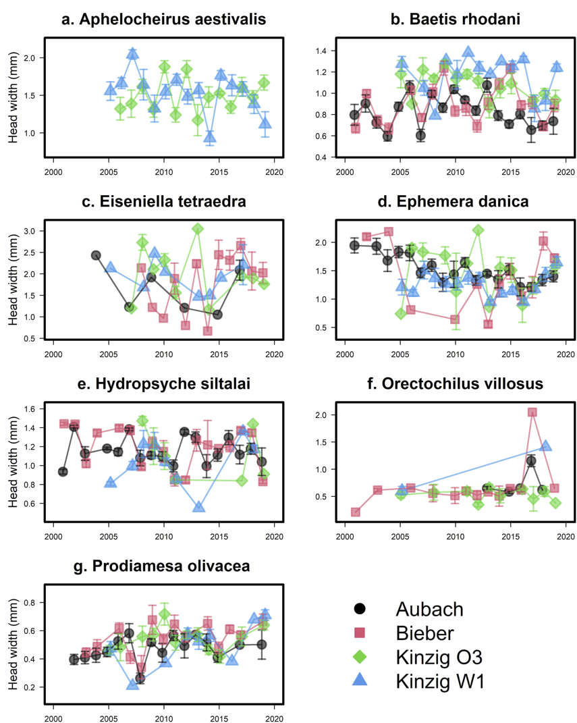

**Figure S1.** Changes in intraspecific head width over time and in the four study sites for nine freshwater aquatic macroinvertebrate species: *Aphelocheirus aestivalis* (a), *Baetis rhodani* (b), *Eiseniella tetraeda* (c), *Ephemera danica* (d), *Hydropsyche siltalai* (e), *Orectochilus villosus* (f), and *Prodiamesa olivacea* (g).

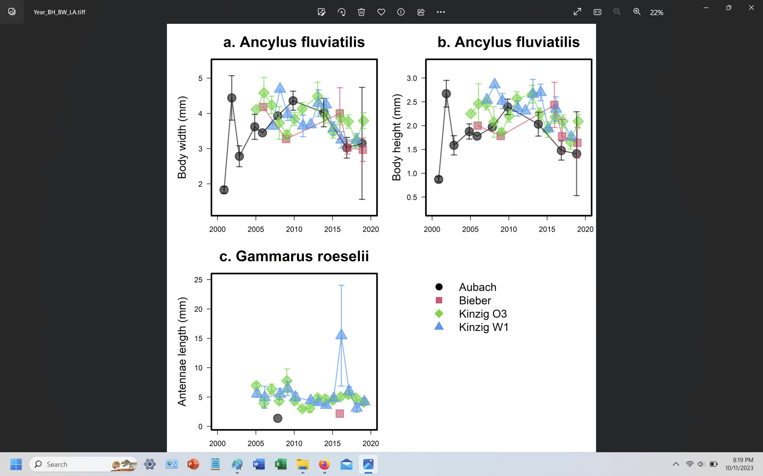

**Figure S2.** Changes in intraspecific body width (a) and body height (b) of *Aphelocheirus aestivalis* and antennae length of *Gammarus roeselii* (c) over time and in the four study sites.

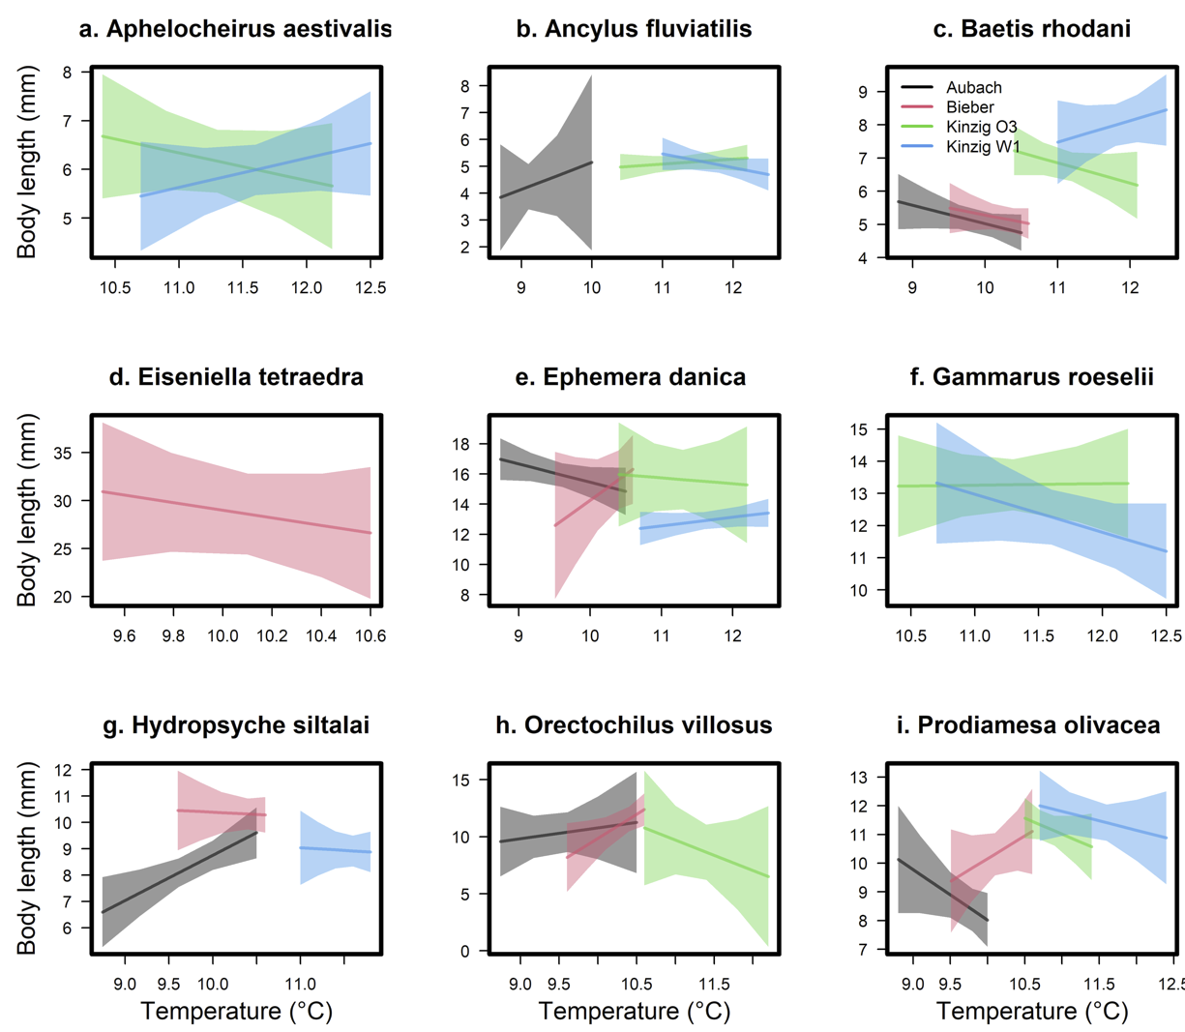

**Figure S3.** Changes in intraspecific body length with water temperature in the four study sites for nine freshwater aquatic macroinvertebrate species: *Aphelocheirus aestivalis* (a), *Ancylus fluviatilis* (b), *Baetis rhodani* (c), *Eiseniella tetraeda* (d), *Ephemera danica* (e), *Gammarus roeselii* (f), *Hydropsyche siltalai* (g), *Orectochilus villosus* (h), and *Prodiamesa olivacea* (i).

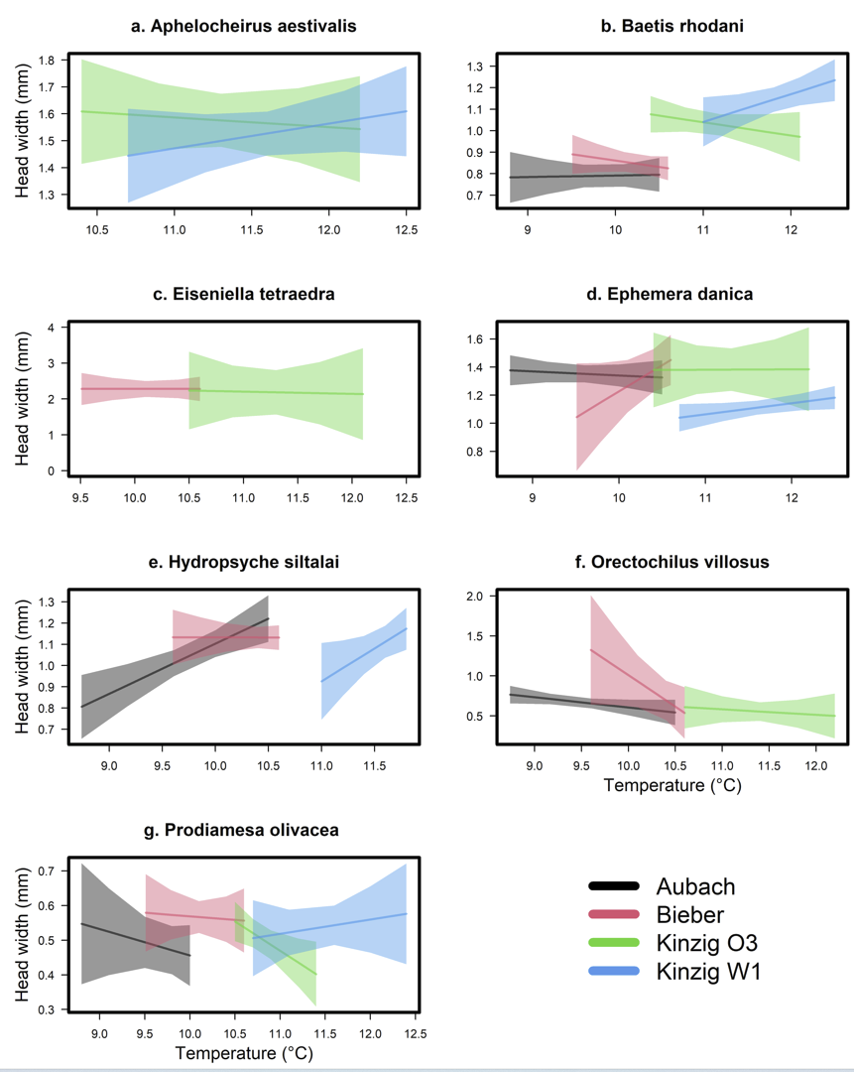

**Figure S4.** Changes in intraspecific head width with water temperature in the four study sites for nine freshwater aquatic macroinvertebrate species: *Aphelocheirus aestivalis* (a), *Baetis rhodani* (b), *Eiseniella tetraeda* (c), *Ephemera danica* (d), *Hydropsyche siltalai* (e), *Orectochilus villosus* (f), and *Prodiamesa olivacea* (g).

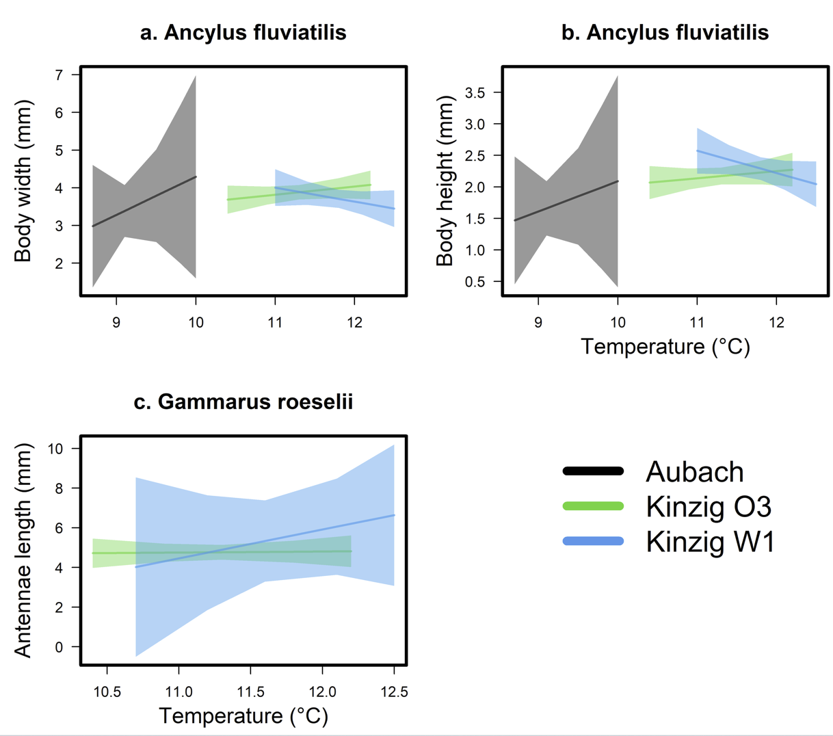

**Figure S5.** Changes in intraspecific body width (a) and body height (b) of *Aphelocheirus aestivalis* and antennae length of *Gammarus roeselii* (c) with water temperature in the four study sites.

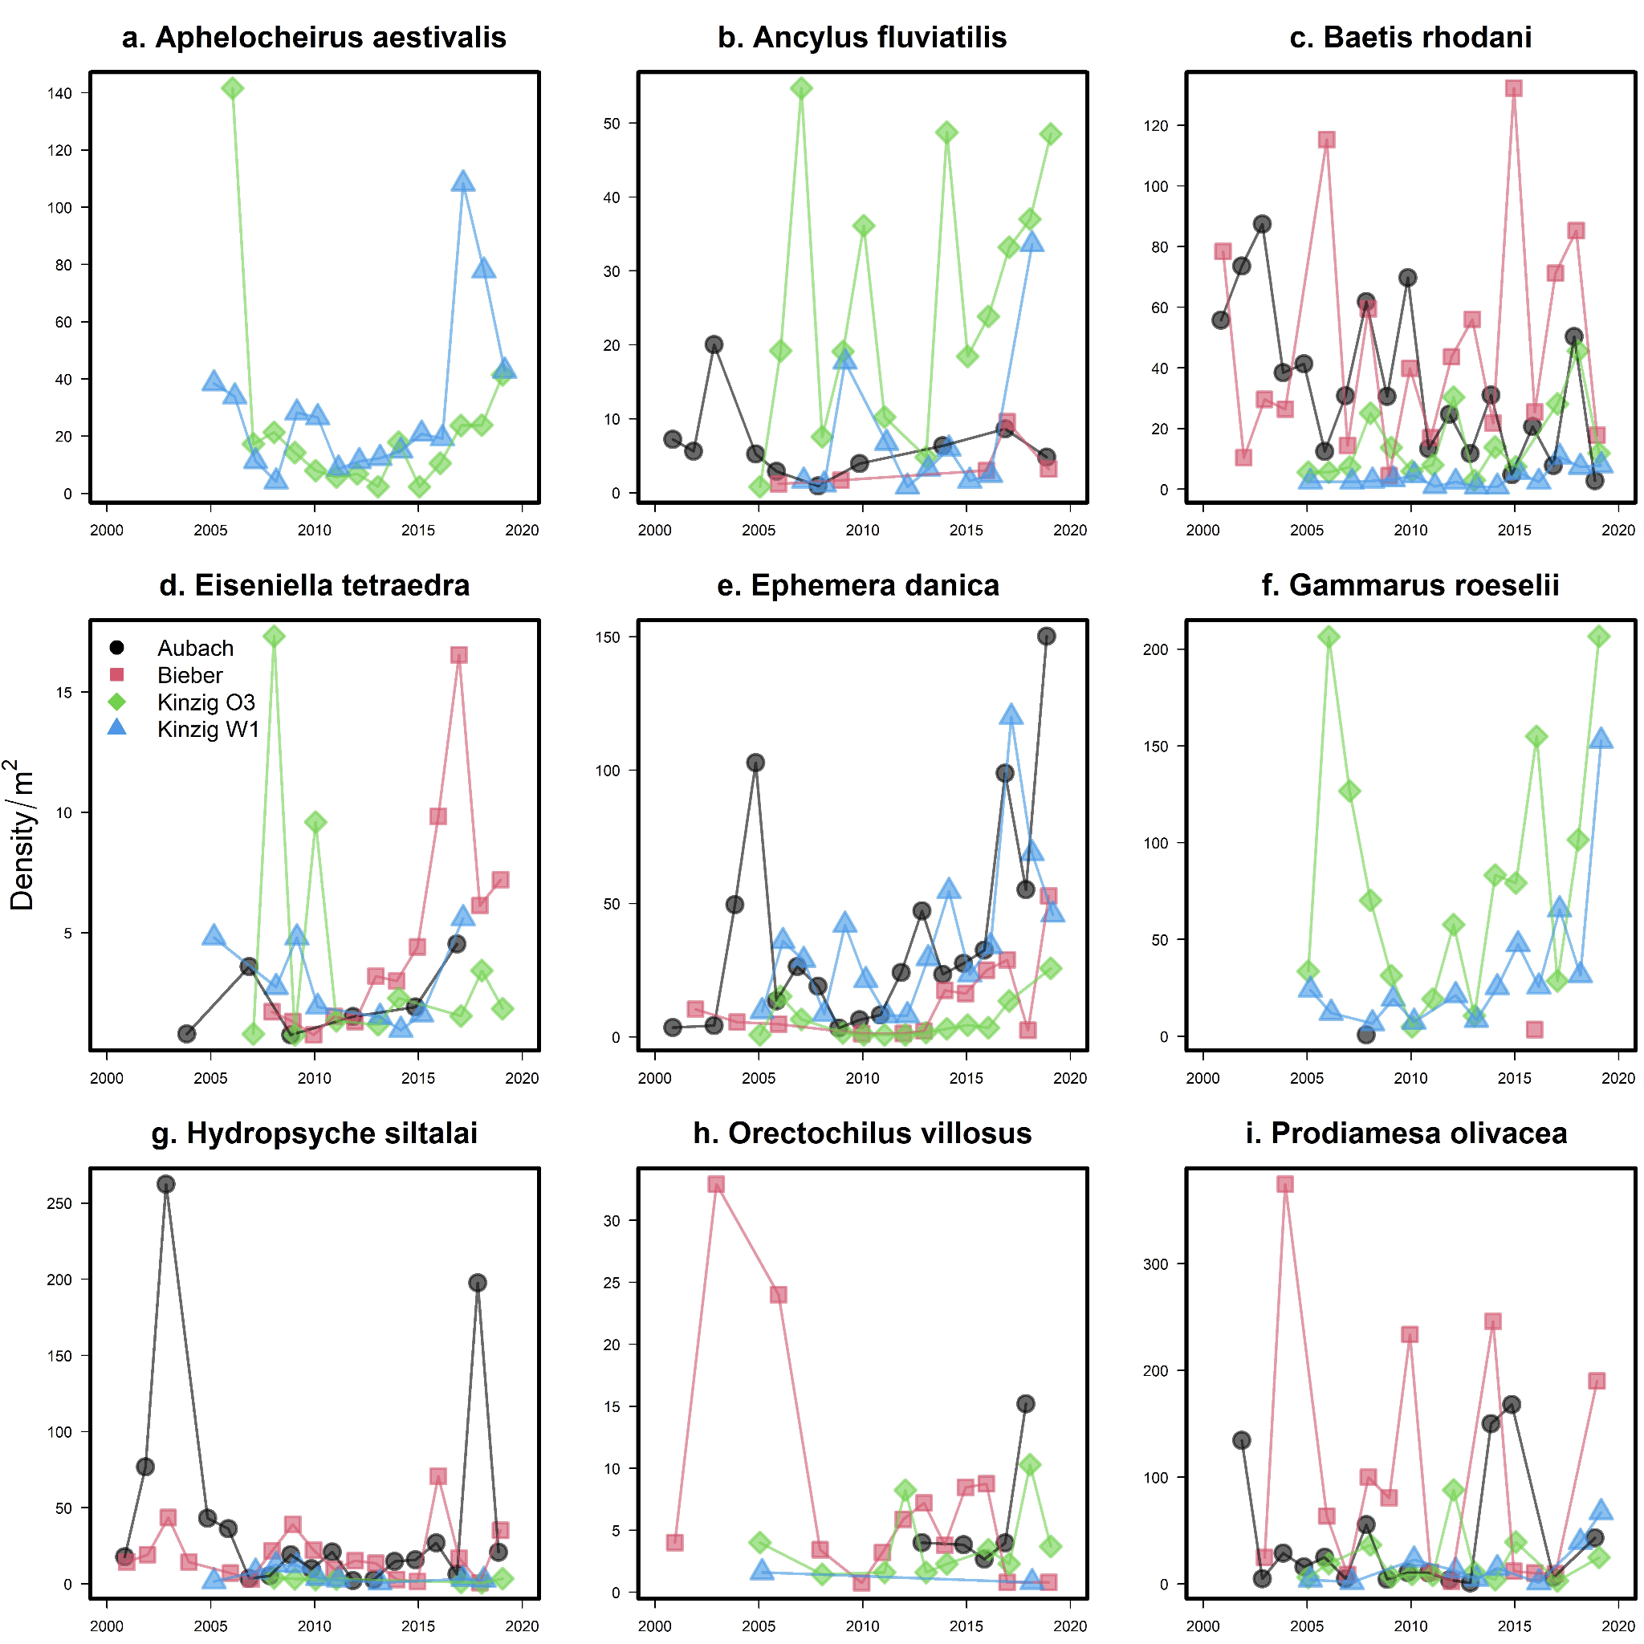

**Figure S6.** Estimated densities of the nine focal macroinvertebrate taxa over the sampling period and the four stream sites. Densities for each site and year were estimated from the linear model function in Program R, including day of year (DOY) in the model (form of the model: lm(density ~ 1 + DOY)).